**Security in Nginx**

We can secure nginx in various ways

**Step 1: Update for latest version**

**Step 2: Hide http headers**

Edit /etc/nginx/nginx.conf file

Add sever_token off;

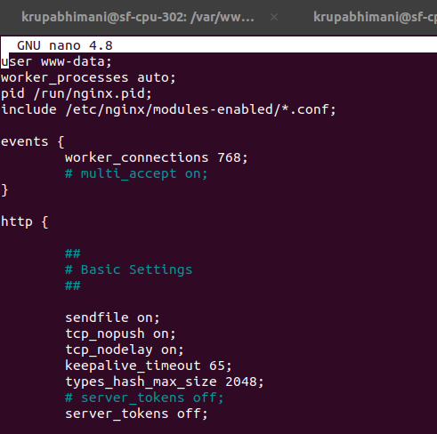

**Step 3: configure SSL**

Configuring SSL will ensure a higher level of protection for your data.

Create directory for SSL certificates

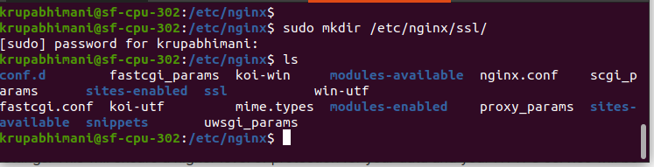

Create self signed certificate using openssl

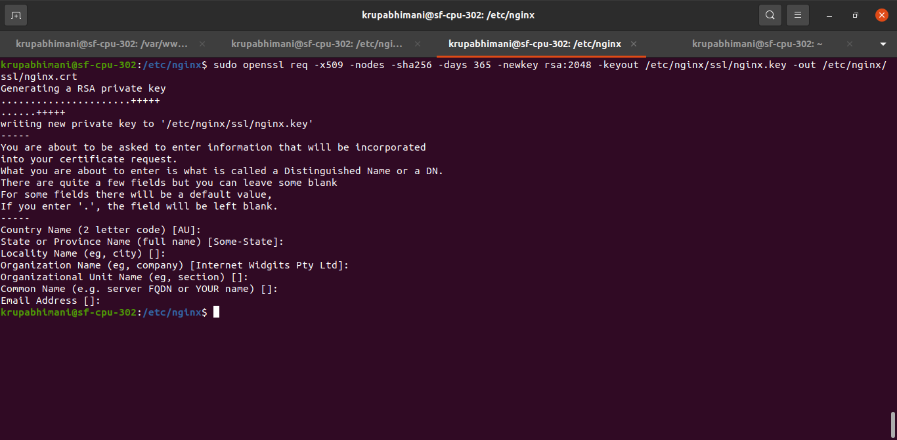

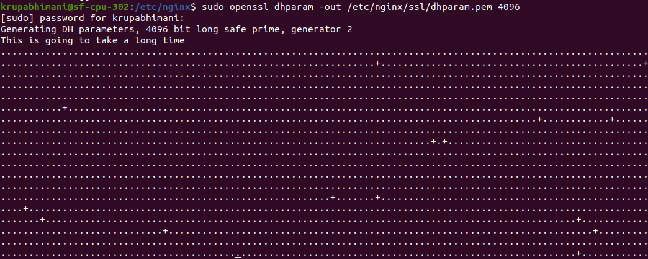

Create snippets

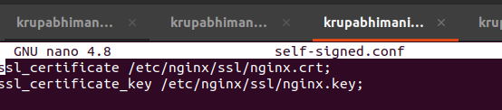

Create another snippet which will define more configuration about ssl

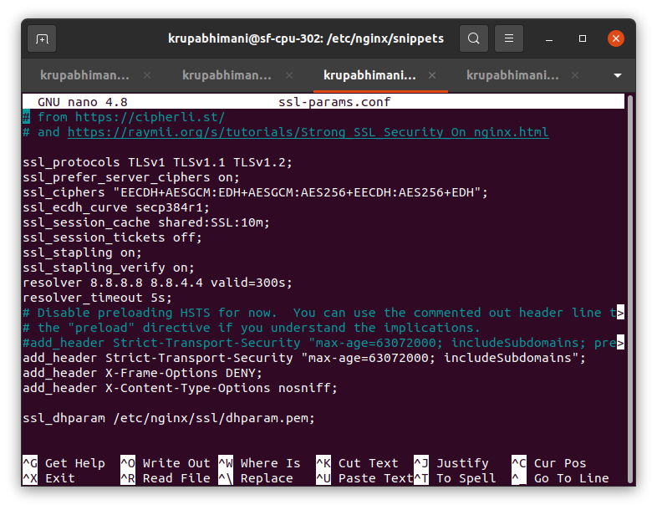

Add configuration to use ssl in file of sites-available

This 2 server block will redirect http request to https

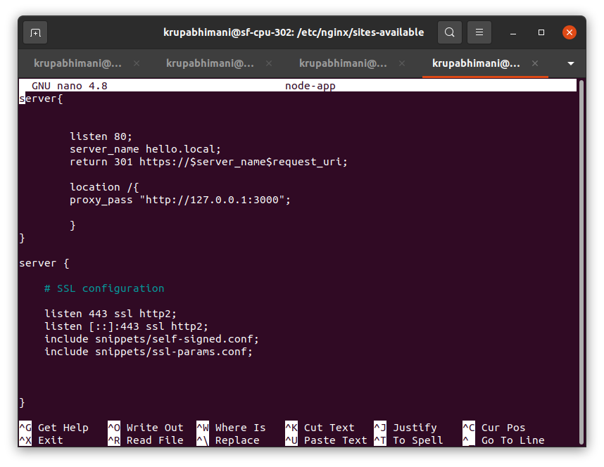

Check status and restart nginx

In browser type localhost

